Harp Sanat Tanıtım Bülteni
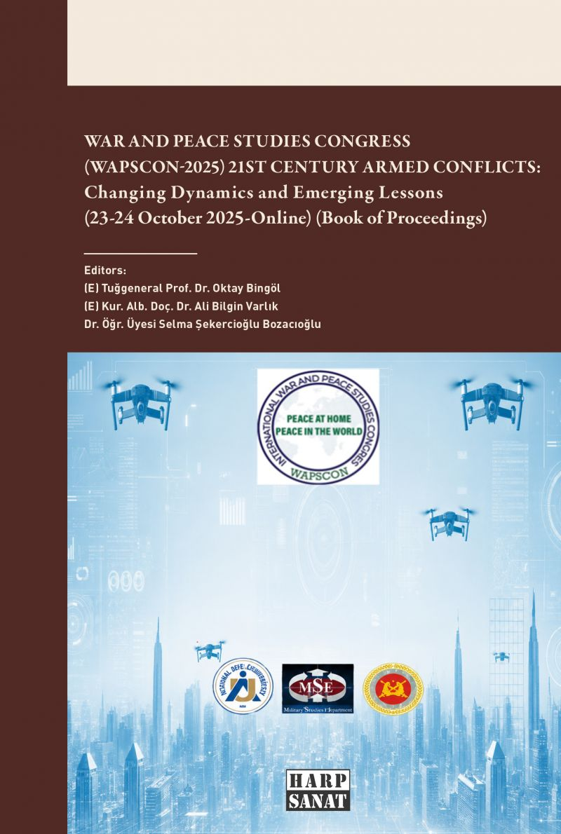 | Eser Adı: War and Peace Studies Cong (Wapscon-2025) 21st Century Armed Conflicts: Changing Dynamics and Emerging Lessons (23-24 October 2025-Online) (Book of Proceedings)  Yazar Adı: Ali Bilgin Varlık  Tür Serisi: Strateji/Derinlik  Cilt Bilgisi: AMERİKAN  Kitap Dili: Türkçe  Eser Tipi: Orjinal  İç Sayfa: 2. HAMUR CMYK 60  Kapak: BRISTOL AMERİKAN 230  Yan Kapak:  Selefon Türü: MAT SELEFON  Basım Tarihi: 2026  Sayfa Sayısı: 670  Kitap Boyutları: 150 X 230 mm  ISBN No: 9786255717153  Etiket Fiyatı: 1.600,00 TL  ISBN Görevlisi: Yusuf Efe Civlez  Editör Görevlisi: Ali Bilgin Varlık  Son Okumacı: Ali Bilgin Varlık  Mizanpajcı: Yusuf Efe Civlez  Kapak Grafikeri: Yusuf Efe Civlez
Kitap Tanıtım Yazısı : (Arka Kapak)

WAR AND PEACE STUDIES CONGRESS-2025 (WAPSCON-2025)“21st Century Armed Conflicts: Changing Dynamics and Emerging Lessons”
Held on 23-24 October 2025, the War and Peace Studies Congress (WAPSCON-2025) brought together distinguished scholars and practitioners to analyse the evolving nature of contemporary warfare. Over the course of two days, the congress featured 45 presentations across 10 sessions, fostering a deep exploration of strategic, operational, and tactical realities in modern combat.The discussions cantered on critical themes, including intelligence and surveillance, command-and-control systems, urban warfare, and the integration of artificial intelligence and robotic systems. Beyond technological and tactical dimensions, the congress also addressed the complexities of naval and air operations, logistics, human security, and humanitarian law.This book of proceedings compiles 23 selected articles that reflect the multidisciplinary breadth of the congress. From the geopolitical implications of emerging technologies to the intricacies of special operations and civil protection, these contributions offer rigorous academic insights into the changing dynamics of 21st-century armed conflicts. It serves as a vital resource for policymakers, military professionals, and researchers dedicated to understanding the lessons learned from the front lines of modern defence.
Kitabın detay sayfasına buradan ulaşabilirsiniz :
https://harpsanat.com/kitaplar/ali-bilgin-varlik-war-and-peace-studies-cong-wapscon-2025-21st-century-armed-conflicts-changing-dynamics-and-emerging-lessons-23-24-october-2025-online-book-of-proceedings-6188.html
Harp Sanat

